Source of Original datset- <https://www.kaggle.com/datasets/dgomonov/new-york-city-airbnb-open-data>

* This data set provides the AirBNB data in NYC from the year 2019. To make all the data clear before we show the questions, answers, and charts, we wanted to explain the data set in a clear and simple way.
* **Pricing**: The average price of an Airbnb rental in New York City is $156.26 per night. The average price of an Airbnb rental in each borough of NYC is as follows: Manhattan has the highest average price at $195.16 per night, followed by Brooklyn at $121.72 per night, Staten Island at $110.69 per night, Queens at $99.70 per night, and the Bronx at $88.31 per night. The highest price ever charged for an Airbnb rental in NYC was $10,000 per night.
* **Reviews**: The average number of reviews per month for all Airbnb rentals in NYC is 1.36. The average number of reviews for Airbnb rentals in each borough of NYC is as follows: Manhattan has an average of 18.60 reviews per rental, Queens has an average of 25.98 reviews per rental, Brooklyn has an average of 21.67 reviews per rental, the Bronx has an average of 24.41 reviews per rental, and Staten Island has an average of 28.47 reviews per rental.
* **Min Nights**: The average number of minimum nights required for Airbnb rentals in each borough of NYC is as follows: Manhattan has the highest average at 8.42 nights, followed by Brooklyn at 6.01 nights, Queens at 5.02 nights, Staten Island at 4.88 nights, and the Bronx at 4.57 nights.
* **Availability**: The average availability of an Airbnb rental throughout the year in NYC is 111.63 days. The average availability of Airbnb rentals in each borough of NYC throughout the year for each room type is as follows:
  + for entire home/apt, Staten Island has the highest average at 175, followed by Bronx at 155 days, Manhattan at 119 days, Queens at 131 days, and the Brooklyn at 94 days.
  + For private rooms, Staten Island has the highest average at 224 days, followed by Bronx at 167 days, Queens at 146.33 days, Brooklyn at 97 days, and Manhattan at 98 days.
  + For shared rooms, Queens has the highest average at 198 days, followed by Brooklyn at 182 days, Manhattan at 137 days, the Bronx at 148 days, and Staten Island at 64 days.
* **Most listings**: There are a total of 43,254 Airbnb rentals in NYC, with 19,068 in Manhattan, 17,629 in Brooklyn, 5,204 in Queens, 1,002 in the Bronx, and 351 in Staten Island. The host with the most listings in NYC is Id: 219517861 - Host name: Sonder (NYC) - Amount: 106929.
* **Types**:In terms of the type of room for each borough, Manhattan has the most Airbnb rentals listed as "entire home/apt" with 674, followed by Brooklyn with 624. Brooklyn has the most "private room" listings with 399, and Manhattan has the most "shared room" listings with 14.
  + Looking at the average price per night for each type of room in each borough, Manhattan has the highest average price for "entire home/apt" at $247.75, followed by Brooklyn at $176.54.
  + For "private room," Manhattan also has the highest average price at $116.62, followed by Brooklyn at $75.39.
  + For "shared room," Manhattan again has the highest average price at $87.66, followed by Queens at $67.42.

Each row in data set and its description

* 1. id: a unique identifier for the airbnb listing;
  2. name: the title of the airbnb listing;
  3. host_id: a unique identifier for the host;
  4. host_name: the name of the host;
  5. neighbourhood_group: the borough in which the property is located;
  6. neighborhood: the neighborhood in which the property is located;
  7. latitude: the latitude of the property's location;
  8. longitude: the longitude of the property's location;
  9. room_type: the type of room being listed (private room, entire home/apartment, or shared room);
  10. price: the price per night for the listing;
  11. minimum_nights: the minimum number of nights a guest must book to stay at the listing;
  12. number_of_reviews: the total number of reviews the listing has received;
  13. last_review: the date of the most recent review;
  14. reviews_per_month: the average number of reviews the listing receives each month;
  15. calculated_host_listings_count: the number of listings the host has on Airbnb;
  16. availability_365: the number of days in a year that the listing is available for booking.

The questions we asked regarding the data set are as follows:

1. What is the average price of an Airbnb rental in New York City?
   1. 156.2620087
2. What is the average price of an Airbnb rental in each borough, and what is the highest?
   1. **Manhattan: 195.1618249- Manhattan has the highest average price for airbnb rentals.**
   2. Brooklyn: 121.7201361
   3. Queens: 99.7012488
   4. Staten Island: 110.6923077
   5. Bronx: 88.31237525
3. What is the average number of reviews per month for all Airbnb rentals in NYC?
   1. 1.369631352
4. How many Airbnb rentals in NYC have a minimum stay of 30 nights or more?
   1. 4500
5. What is the average availability of an Airbnb rental throughout the year in NYC?
   1. 112.6201449
6. What is the highest price ever charged for an Airbnb rental in NYC?
   1. 10000
7. How many Airbnb rentals are there in each borough of NYC?
   1. Bronx: 1080
   2. Brooklyn: 20058
   3. Queens: 5630
   4. Manhattan: 21600
   5. Staten Island: 369
8. What is the average number of minimum nights required for Airbnb rentals in each borough of NYC?
   1. Bronx: 4.587962963
   2. Brooklyn: 6.061521587
   3. Queens: 5.188632327
   4. Manhattan: 8.587546296
   5. Staten Island: 4.853658537
9. Which host has the most listings in NYC, and how many listings do they have?
   1. Id: 219517861 Host name: Sonder (NYC) Amount: 106929
10. How many Airbnb rentals in each borough of NYC are listed as "entire home/apt" versus "private room" or "shared room"?
    1. Entire home/apt: 1370
    2. Shared room: 27
    3. Private room: 884
11. What is the average number of reviews for Airbnb rentals in each borough of NYC?
    1. Bronx: 24.40818363
    2. Brooklyn: 21.66817924
    3. Manhattan: 18.60041951
    4. Queens: 25.98174832
    5. Staten Island: 28.47293447
12. What is the type of room for each borough and how many of that type do they have?

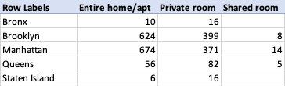

1. What is the average price per night for each type of room (entire home/apt, private room, shared room) in each borough of NYC?

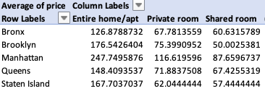

1. What is the average availability of Airbnb rentals in each borough of NYC throughout the year for ever room type? (days)

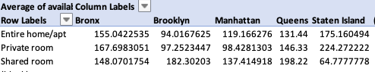

1. What is the average minimum amount of nights for each borough for each type of room in nyc?

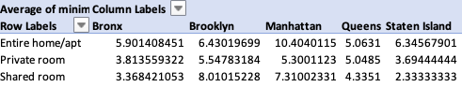

Average price per borough with room type: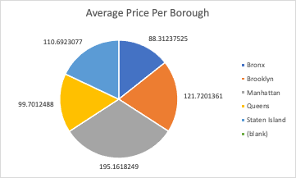

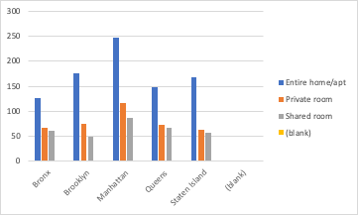

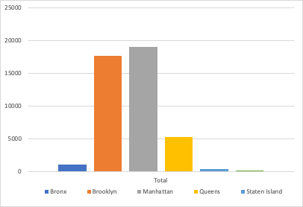

Most Listings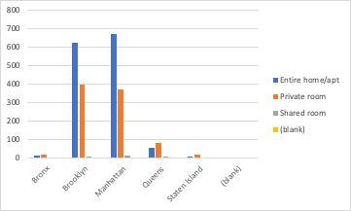

Room Type Per Borough